Course Data
Grade Level: 6th
Unit Topic: Language Arts – Theme “Technology”
Lesson Topic: Setting
Length of Lesson: 45 min.

Standards
GLE 0601.8.4 Analyze works of literature for what is suggested about the historical period in
which they were written.
0601.8.8 Identify the plot element of exposition (i.e., introduction of characters, setting,
and conflict) in literary texts.
0601.8.9 Identify and analyze the setting (location and time) and its impact on plot,
character, and theme in literary texts.

Materials
Promethean Board & Flipchart with Set/Focus
Graffiti- Markers (different color for each group)
Posters for each Graffiti station

Lesson Objectives
TSWBAT identify the various components of setting: Place, Time, Weather conditions, Social conditions, Mood/Atmosphere.
TSWBAT analyze the impact of setting on a story with a brief response “exit slip.”
TSWBAT relate setting to the over-arching theme of “technology.”

Anticipatory Set/Focus
ABK | Show students 3 pictures at a time that represent a particular “setting.” (3 pictures for each setting: Beach, City, Farm, winter, old west). Pictures in flipchart format on Promethean.
IA | As students look at each set of pictures:  What do these pictures have in common?  Let individual students guess answers, and whole class confirm (agree/disagree) After all three sets, see if they can guess the main idea (Setting), which was introduced on Monday.
RRL | Can you think of a time when you share stories with friends in which you incorporate setting? What about when you tell people about your summer vacation, where you went & what you did? Why might is setting important to a story or a picture?
LL | Today we are going to take a closer look at setting and its role in literature.

Instruction: Graffiti
- Set/Focus
- Break students into groups for Graffiti. Have one group start at each Graffiti stations. Each station is named for one of the functions of setting:
Mood/Atmosphere
Social Conditions
Weather conditions
Time
Place
- With each setting type, a simple description/definition is included. Student groups are to record possible examples of each setting type that they have seen in a story/movie, or just one they make up. They will write their ideas on the poster, and then rotate.
- After they have rotated through all of the posters, on the last one, the group is to come up with an example from Hatchet.
- The groups then go through the rotation again, reading what others wrote and marking (with stickers) what they think is their favorite. They also are to read/add to the connection to Hatchet.
- Students return to their individual desks.
- As a class, discuss what seems to have the most stickers (favorited by most the class).
- Pass out Exit Slip.

Assessment
Informal | Formal
Monitor graffiti process and group discussions.  Look over graffiti posters as they write/ fill them out. Bring up any inconsistencies during discussion.  Ask student groups to rationalize their ideas as you travel to different groups. | Exit Slip  Graffiti Posters

Closure
Have students recite the types of setting. Ask them what types they saw in Hatchet. Have them complete an exit slip.

Set/Focus

What do these pictures have in common?
(BEACH)
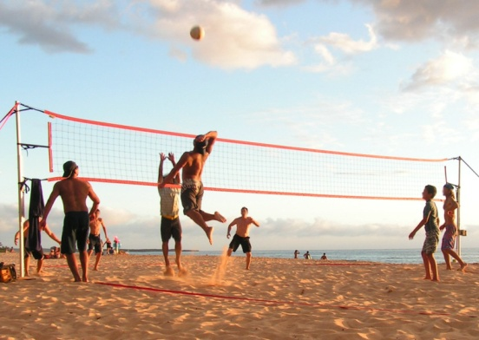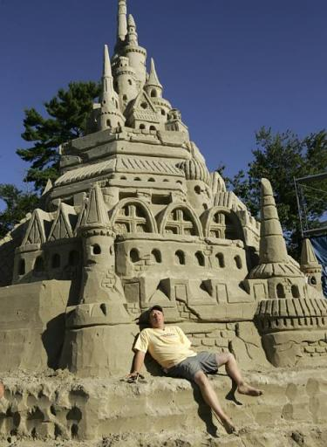

(CITY)
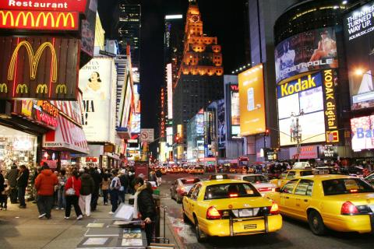

(FARM)
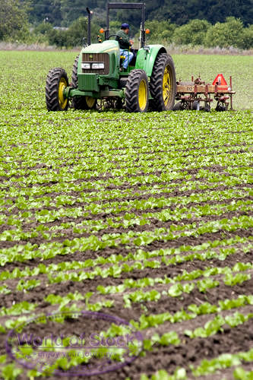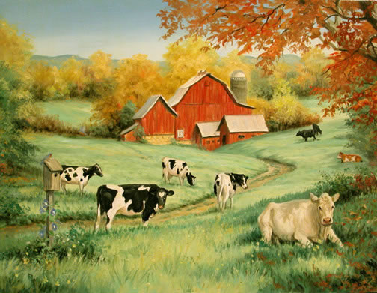

(WINTER)
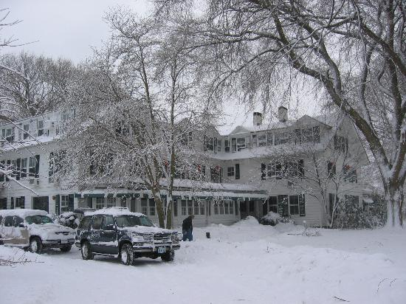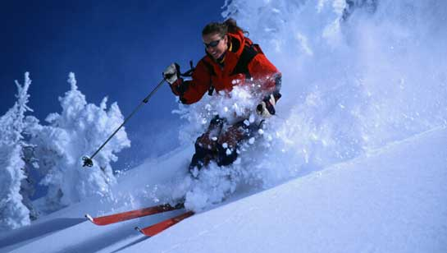

(History/Past)
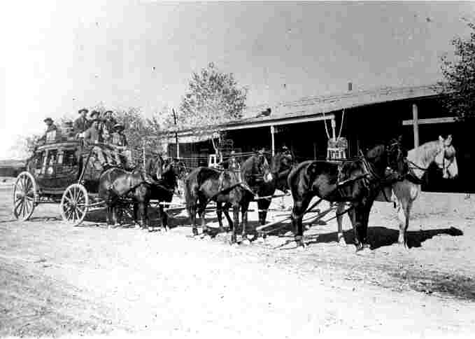
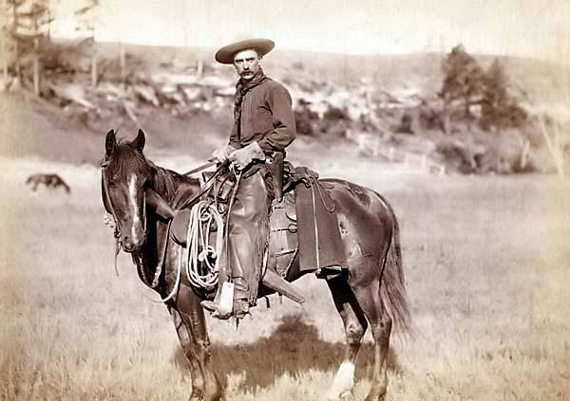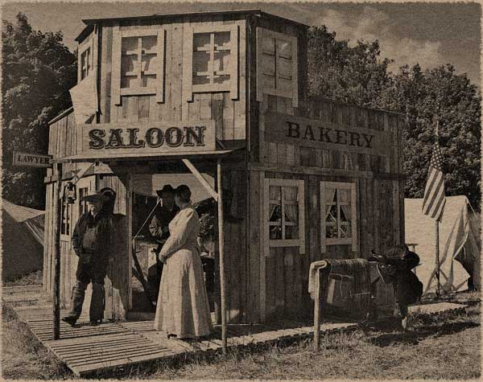
Exit Slip: Setting
Name___________________ Date________________

Directions: In a brief response (3-5 sentences), answer the following.

How the setting in Hatchet influences the rest of the story. How might it have been different if it took place somewhere else?

How can we relate setting to our theme of “technology”?

